African Wild Dog Dispersal and Connectivity under Climate Change - Lessons Learned from Seasonal Flood Extremes

David D. Hofmann1,2,§ Dominik M. Behr1,2 John W. McNutt2

Arpat Ozgul1,2 Gabriele Cozzi1,2

July 24, 2023

1. Department of Evolutionary Biology and Environmental Studies, University of Zurich,

Winterthurerstrasse 190, 8057 Zurich, Switzerland.

1. Botswana Predator Conservation Program, Wild Entrust, Private Bag 13, Maun,

Botswana.

§ Corresponding author: david.hofmann2@uzh.ch

**Running Title:** African Wild Dog Dispersal in a Changing Climate: Lessons Learned from Seasonal Flood Extremes

**Keywords:** movement, connectivity, climate change, seasonality, dispersal, conservation, individual-based simulations, step-selection

**Abstract**

While climate change has been shown to impact the life history of wild-living animal populations, little is known about its effects on dispersal and connectivity.

Here, we capitalize on the highly dynamic flooding patterns of the Okavango Delta ecosystem to investigate the impacts of changing environmental conditions on dispersal patterns and connectivity of an endangered species, the African wild dog (*Lycaon pictus*). Using a movement model parametrized with data collected on dispersing individuals, we simulate 12’000 dispersal trajectories across the ecosystem under two extreme environmental scenarios: a minimum and a maximum flood extent, characterized by surface-water coverage of 3’500 km2 and 9’500 km2, and representative of very dry and very wet environmental conditions. These two scenarios reflect environmental conditions akin to those under amplified climatic variability, as it is expected under climate change.

Across the entire ecosystem, surface water coverage during maximum flood extent reduced the propensity of individuals to disperse between adjacent areas (i.e. dispersal success) by 12% and increased dispersal durations by 17%. Locally, however, dispersal success diminished as much as 78% and dispersal durations increased by 19%. Depending on the flood extent, alternative dispersal corridors emerged, some of which in the immediate vicinity of human-dominated landscapes. Notably, under maximum flood extent, the number of trajectories moving into human-dominated landscapes decreased by 40% at the Okavango Delta’s inflow, but increased by 124% at the Delta’s distal end. This may drive the emergence of hotspots for human-wildlife conflict.

Whilst predicting the impacts of climate change on on-the-ground environmental conditions remain challenging, our results highlight that environmental change may have stringengt consequences for dispersal patterns and connectivity. Acknowledging and anticipating such impacts will be key to design effective conservation strategies and to preserve vital dispersal corridors in light of climate change and other human-induced perturbances.

**Contents**

**1 Introduction** **1**

1.1 Overview 1

1.2 Dispersal & Connectivity 1

1.3 Dispersal & Connectivity under Climate Change 2

1.4 Climate Extremes 2

1.5 Okavango Delta 3

1.6 What We Did 3

**2 Materials and Methods** **4**

2.1 Study Area 4

2.2 Spatial Habitat Layers 5

2.3 Source Areas and Emigration Zones 5

2.4 Dispersal Simulation 6

2.5 Derived Metrics 7

**3 Results** **8**

**4 Discussion** **9**

4.1 Brief Summary 9

4.2 Validating Predictions 10

4.3 Climate Change in the Okavango Delta 11

4.4 Social Resistance 12

4.5 Anthropogenic Resistance 13

4.6 Human Wildlife Conflict 14

4.7 Conclusion 15

4.8 To Scavenge: For the Introduction 16

4.9 To Scavenge: For Discussion 17

**5 Authors’ Contributions** **17**

**6 Data Availability** **17**

**7 Acknowledgements** **17**

# Introduction

## Overview

Climate change is expected to profoundly impact ecosystems across the globe with farreaching consequences for the species living therein (Ozgul et al., 2010; Radchuk et al., 2019;

IPCC, 2022). By altering environmental conditions, climate change affects animal behavior (Fuller et al., 2016), resource availability (Durant et al., 2007), population dynamics (Paniw et al., 2021), and the distribution of wild living animal populations (Thomas et al., 2004; Thuiller et al., 2006). An important life-history pathway through which species may mediate the negative consequences of climate change is dispersal (Anderson et al., 2012), i.e. the movement of individuals away from their natal location to the site of first reproduction (Clobert et al., 2012). However, little is known about the impacts of climate change on the

dispersal.

## Dispersal & Connectivity

Dispersal promotes resilience against changing environmental conditions by fostering genetic variability (Frankham et al., 2002; Leigh et al., 2012), facilitating the colonization of empty habitats (Gustafson and Gardner, 1996; Hanski, 1999; MacArthur and Wilson, 2001), and reinforcing weakend subpopulations (Brown and Kodric-Brown, 1977; MacArthur and Wilson, 2001). It has also been suggested that species use dispersal to track favorable habitat conditions (Raia et al., 2012) and shift into different regions of their fundamental niche (Kokko, 2006). While dispersal acts as a means to offset the impacts of climate change, it is itself a function of climatic and environmental conditions (e.g. Elliot et al., 2014; Hofmann et al., 2023). This link can be *indirect*, for example if the propensity of individuals to disperse depends on environmental conditions (Bowler and Benton, 2005; Behr, 2021), or *direct*, when the biophysical enivonment through which dispersers move affects dispersal prospects (Travis et al., 2013; Hofmann et al., 2023). The latter case highlights that dispersal is contingent on a sufficient degree of landscape connectivity (Fahrig, 2003; Baguette et al., 2013), which is why conservation strategies aimed at facilitating dispersal by improving landscape connectivity are often viewed as pinnacle of all conservation strategies (Heller and Zavaleta,

2009).

## Dispersal & Connectivity under Climate Change

Despite the importance of dispersal and connectivity for population dynamics and conservation efforts, predicting how these ecological processes respond to environmental change remains challenging (Littlefield et al., 2019). This is owed to a lack of data on dispersing animals at the appropriate spatio-temporal scales (Graves et al., 2014; Vasudev et al., 2015) and due to limited information of environmental conditions under climate change (Scheiter and Higgins, 2009; IPCC, 2022). One strand of literature combines future climate scenarios with species distribution models to predict future species ranges and to study the impacts of range shifts on *structural* connectivity (Wasserman et al., 2012; Ashrafzadeh et al., 2019; Luo et al., 2021). The employed climate scenarios contain vital information about atmospheric conditions (temperature, precipitation) under climate change, they typically fail to translate such information into ground-level landscape characteristics (vegetation cover, surface-water). Another body of literature, albeit not primarily focused on climate change, investigates how environmental change through seasonality affects *functional* connectivity (e.g. Mui et al., 2017; Osipova et al., 2019; Zeller et al., 2020; Kaszta et al., 2021). This is typically achieved using seasonally updated resistance surfaces that depict the ease or difficulty at which the focal species can traverse a specific area in a specific season (Zeller et al., 2012). Despite the biological relevance of this approach to understanding seasonal variability, it suffers from the short time span at which processes are investigated and prohibits inferences on the effect of climate change on dispersal and connectivity.

## Climate Extremes

Given that climate change will increase the frequency of extreme events, such as severe droughts, heavy precipitation, floods, and storms (Stott, 2016; Ummenhofer and Meehl, 2017; IPCC, 2022), we argue that a focus on extreme, rather than seasonal, events could serve as a robust way to learn about the impacts of climate change on connectivity. That is, instead of studying the impacts of climate change directly, one may capitalize on naturally occurring fluctuations of the environment to gauge the likely consequences of shifting the system towards what is currently considered an extreme. Such an approach appears particularly useful in cases where data on future environmental conditions are difficult to obtain or plagued by uncertainty (Collins et al., 2012).

## Okavango Delta

The Okavango Delta (OD) ecosystem in Southern Africa offers a unique opportunity to study the impacts of extreme environmental changes on species dispersal and connectivity in a large-scale natural experiment setup. The OD is the world’s largest inland delta and characterized by major differences in flood extent. The area covered by the OD’s floodwaters can fluctuate between 3’500 and 14’000 km2 with striking variability within and between years (Gumbricht et al., 2004; Wolski et al., 2017). The region is among the most vulnerable to climate change, as temperature increases of 4 to 6 C above pre-industrial levels are expected within the 21st century (Engelbrecht et al., 2015; Akinyemi, 2019), which is far above the global average (IPCC, 2022). Despite the importance of the OD as a driver of ecosystem functioning (Wolski and Murray-Hudson, 2008), species distribution (Bonyongo, 2005; Bennitt et al., 2014), and dispersal corridors (Hofmann et al., 2021), predicting its flooding regime under climate change has proven notoriously difficult (Wolski and Murray-Hudson, 2008). A keystone predator in this ecosystem and an umbrella species for conservation efforts is the African wild dog (AWD, *Lycaon pictus*). While the species was once widespread across Sub-Saharan Africa, it has disappeared from a vast majority of its historic range, mainly due to human persecution, infectious diseases, and continued degradation and destruction of its habitats (Woodroffe and Sillero-Zubiri, 2012). AWDs are characterized by a remarkable dispersal ability, as young individuals that leave their natal pack can cover several hundred kilometers within a few days (e.g. Cozzi et al., 2020). Dispersal typically happens in dispersal coalitions of same-sex siblings (McNutt, 1996). Previous research by (Hofmann et al., 2021, 2023) on dispersing individuals has shown that water represents a major barrier to dispersal, yet this analysis omitted any investigation of the effects of fluctuating and extreme environmental conditions.

## What We Did

Utilizing a previously validated individual-based movement model parametrized with empirical data on dispersing AWDs, we simulate 12’000 AWD dispersal trajectories to assess dispersal succes and durations, map major dispersal corridors, and identify areas with elevated potential for human-wildlife conflict (HWC) under two extreme environmental scenarios: one assuming maximum flood extent, representing above-average wet climatic conditions, and one assuming minimum flood extent, representing actue dry conditions. We anticipate lower dispersal success and connectivity, as well as an increased propensity to emigrate from the study area during maximum flood. Moreover, we expect major dispersal corridors to differ between minimum and maximum flood, thus resulting in differing corridor arrangements and therefore changes in the likely hotspots for HWC.

# Materials and Methods

We conducted all data preparation and analyses using the programming language R (R Core Team, 2022). For any spatial data manipulation, we used the packages terra (Hijmans et al., 2023) and spatstat (Baddeley et al., 2015). Several helper functions for the dispersal simulation algorithm were written in C++ and imported to R using the Rcpp package (Eddelbuettel and Fran¸cois, 2011). Network analysis was achieved in igraph (Csardi and Nepusz, 2006) and figures were generated using ggplot2 (Wickham, 2016) and ggnetwork (Briatte, 2021).

All R-scripts required to replicate our analyses are provided through an online repository.

## Study Area

The broader study area comprised the OD and its surroundings, covering parts of Angola, Namibia, Botswana, Zimbabwe, and Zambia (Figure 1). While our main focus lied on the immediate surroundings of the OD (hereafter referred to as *core study area*, enclosed by the purple polygons in Figure 1b), we accommodated for the long-distance dispersal events observed in this ecosystem (Cozzi et al., 2020; Hofmann et al., 2021) by considering a relatively large rectangular study extent spanning from 17 30’ S to 21 30’ S and 20 30’ E to 26 E, covering an expanse of 300’000 km2 (Figure 1b). The flood extent of the OD is mainly driven by precipitation in the catchment areas in the Angolan highlands, from where water is channeled into the Cubango/Cuito Basin and discharged into the OD. Local rains and ground water table levels resulting from floods of previous years can marginally impact annual flood levels too. During minimum flood extent, representing particularly dry years, the flood in the OD may cover as little as 3’500 km2, whereas during maximum flood extent, representing particularly wet years, an area up to 14’000 km2 is inundated (McCarthy et al., 2003; Gumbricht et al., 2004). Once the floodwater reaches the OD’s distal ends, it perlocates at the Thamalakane and Kunyere Faults, two natural faultlines at which the waterflow is hindered. Vegetation in the study area is dominated by mopane forest (*Colophospermum mopane*), mixed woodland acacia-dominated (*Acacia spp.*, and grassland). Human influence is low and mainly concentrated around small villages at the western and southern periphery of the OD. The largest urban center is Maun, a spread-out city at the south-eastern tip of the OD. Large portions of land are gazetted as national parks, game reserves, or forest reserves and the study area forms part of the world’s largest transboundary conservation initiative, the Kavango-Zambezi Transfrontier Conservation Area (KAZA-TFCA). Previous studies attributed a high potential of this initiative for improving connectivity for various species (Brennan et al., 2020; Lines et al., 2021; Hofmann et al., 2021).

## Spatial Habitat Layers

We represented the physical landscape through which dispersers could move by a set of spatially referenced habitat layers, each with a resolution of 250 m. The set of layers included water-cover, distance-to-water, tree-cover, shrub/grassland-cover, and a composite human influence layer representing villages, roads, and agricultural areas. A detailed description of the different habitat layers is provided in (Hofmann et al., 2021). Notably, we generated the water-cover layers using MODIS Terra MCD43A4 satellite imagery that was classified into binary water-cover maps using an algorithm developed by (Wolski et al., 2017) and implemented in R [(https://github.com/DavidDHofmann/floodmapr)](https://github.com/DavidDHofmann/floodmapr). This allowed us to generate weekly updated “floodmaps”, thus providing detailed information about the floodextent at any given point in time. In total, we generated 700 floodmaps, covering the years 2000 to 2019. We then used these maps to produce minimal and maximum flood scenarios, representative of dry and wet climatic conditions. To create the minimum (respectively maximum) flood scenario, we averaged the 100 floodmaps with the smallest (highest) flood extent and generated a binary layer by masking all pixels that were inundated in less than 50% of the maps. By averaging across 100 floodmaps, we followed a conservative approach and mitigated chances of misrepresenting minimum and maximum flood extent due to inaccuracies in single remote sensed floodmaps. The resulting maps are presented in Figure 2 and show that the flood in the two scenarios covers 3’500 km2 and 9’500 km2, respectively. We combined the set of habitat layers into two stacks, one representing the minimum flood scenario, one representing the maximum flood scenario. To prevend edge effects during the dispersal simulation, we followed Koen et al. (2010) and expanded the spatial extent of the stacked layers by 20%, filling the so created buffer zone (gray buffer in Figure 1b) with randomized values from the respective layers. This would allow simulated dispersers to leave and re-enter the main study are via a randomized buffer zone.

## Source Areas and Emigration Zones

We simulated dispersing AWDs originating from distinct source areas location within the main study area in Figure 1b. We selected source areas in regions that remained dry during both scenarios and are known to host viable AWD populations. Defining these areas was necessary to enable identification and quantification of the number of successful dispersal events between different regions of the core study area across the two flood scenarios. THe OD’s hydrography resulted in a natural latitudinal split between areas 1, 2, and 3 in the east and areas 4 and 5 in the west (Figure 1b). Areas 1, 2, and 3 were further separated longitudinally by the Selinda Spillway, a waterway that connects the OD with the Linyanti Swamp, and by the Khwai River, which inundates the Mababe Depression east of the OD.

On the western side of the OD, areas 4 and 5 were longitudinally separated by the Thaoga River drainage at Nokaneng (Figure 1b). Finally, the OD hosts a central island, known as Chief’s Island (area 6 in Figure 1b). Besides source areas 1 to 6, we also generated “emigration zones” that we used to determine *if* and *where* simulated individuals left the delta’s immediate surroundings (Figure 1b). We generated these zones by first overlaying the OD with an ellipse that we dissected into equally sized polygons in accordance with cardinal directions (Figure 1b).

## Dispersal Simulation

We used a previously parameterized and validated dispersal model to simulate dispersal of AWDs. The dispersal model was trained using GPS data of 16 wild dog coalitions dispersing across northern Botswana (Hofmann et al., 2023) which was fed into an integrated step-selection function (iSSF, Avgar et al., 2016). In iSSFs, consecutive GPS locations are converted into steps (the straight-line traveled between two GPS recordings (Turchin, 1998)) and compared to a set of *random* steps in a conditional logistic regression framework (Fortin et al., 2005; Thurfjell et al., 2014; Muff et al., 2020; Fieberg et al., 2021). Because iSSFs capitalize on the autocorrelated nature of the collected data, they provide better estimates of connectivity than traditional resource selection approaches (Zeller et al., 2016). The model presented in Hofmann et al. (2023) comprised of a movement kernel, describing how dispersers move across the landscape in the absence of habitat selection, a habitat kernel, indicating preferred or avoided habitat features, and interactions among the two, i.e. how movement behavior changes depending on habitat conditions. According to this model, the main characteristics of AWD dispersal movements are avoidance of water, avoidance of areas influenced by humans, and a preference for directional and fast movements. The model parameters are provided in Appendix SX and explained in Hofmann et al., 2023.

Originating from each of the six source areas, we simulated 2’000 individuals dispersing for a total of 2’000 steps. 1’000 individuals were simulated assuming a minimum flood, the remaining 1’000 assuming a maximum flood. This resulted in the simulation of a total of 12’000 individuals. The simulation procedure was based on the algorithm described in Hofmann et al. (2023) and works as follows. A random location within the source area is defined as starting point. Originating from the starting point, a set of 25 random steps is generated by sampling step lengths from a gamma distribution fitted to observed steps (shape = 0.37, scale = 6’316) and turning angles from a uniform distribution (−*π,*+*π*). Along each random step the underlying spatial covariates are extracted, and relevant movement metrics are computed. *β*−estimates from the fitted model are used to predict the probability of each step for being chosen, given the steps associated covariates. Among the 25 proposed steps, one is chosen at random based on assigned probabilities. The location of the animal is updated, and the procedure is repeated until the desired number of steps is realized. Here, we simulated each individual for 2’000 steps, corresponding to a dispersal duration of

400 days and the longest dispersal duration recorded in this study area (Cozzi et al., 2020; Hofmann et al., 2021). The simulated trajectories can be understood as correlated random walks.

## Derived Metrics

Based on simulated dispersal trajectories we quantified connectivity and identified areas of elevated potential for human wildlife conflict. Our assessment of connectivity was based on the three complementary connectivity metrics for IBMMs discussed in Hofmann et al. (2023). The set of metrics comprised of *heatmaps*, depicting areas of intense use, *betweenness maps*, highlighting dispersal corridors and bottlenecks and *maps of inter-patch connectivity*, visualizing dispersal success, and duration into distinct habitat patches. We generated heatmaps by superimposing the study area with a grid with a spatial resolution of 1 km and quantifying the frequency of simulated trajectories traversing each grid cell. To compute spatially mapped betweenness scores, we overlaid the study area with a grid that had a resolution of 2.5 km and determined the frequency at which simulated individuals transitioned from one grid-cell to another. A cell-transition was said to occur whenever a simulated step crossed from one grid-cell across or into another. In case the same individual repeatedly realized the same cell-transition, we only counted a single transition to avoid emphasis on regions where individuals moved in circles. This resulted in a weighted edge-list that we used to compute weighted betweenness scores for each grid-cell, i.e. the importance of the respective grid-cell in facilitating movement into adjacent areas (Bastille-Rousseau et al.,

2018; Bastille-Rousseau and Wittemyer, 2021). Betweenness was computed using the igraph

R-package (Csardi and Nepusz, 2006). Because the computations associated with calculating betweenness scores are computationally more demanding, we deemed the grid size of 2.5 km a sensible compromise between efficiency and resolution. As a final connectivity metric, we computed the number of successful dispersal events between each of the six distinct source areas. We coin this type of connectivity “inter-patch connectivity”. Dispersal between two areas was said to be successful whenever the trajectory of an individual leaving one area intersected with the polygon of another area. We also estimated the number of individuals that left the OD’s vicinity and moved into an emigration zone. To quantify the dispersal durations required to move between source areas or into emigration zones, we recorded the minimum number of steps that individuals moved before arriving at the respective destination. Besides connectivity, we also identified zones with a high potential for human wildlife conflict. For this, we isolated all simulated locations where simulated individuals moved within 500 meters of the nearest human-influenced grid-cell. Based on the so isolated coordinates we generated density maps. To highlight differences between derived metrics during maximum and minimum flooding, we computed difference maps for the heatmap, betweenness map, and human wildlife conflict maps.

# Results

Figures depicting the derived connectivity and human-wildlife conflict maps are provided in Figure 5. Difference maps to visualize the differences between minimum and maximum flood are given in. For brevity, we will here focus on system-wide connectivity patterns and only selectively point to regional results. Local connectivity maps derived for each source-area separately are presented in the Appendix. As the heatmaps in Figure 5a reveal, the OD acts as major dispersal barrier during maximum flood yet reveals vital dispersal habitat during minimum flood. Differences between maximum and minimum flood are particularly pronounced for the region between source areas 1 and 2, where few dispersers occur during times of maximum flood. In fact, because the floodwaters of the OD reach almost into Maun, the OD creates a line of separation between its eastern and western sections. The separation is further amplified as the city of Maun is avoided by dispersers in both scenarios. Similar patterns are observed on the betweenness maps (Figure 5b), where several pinch-points and bottlenecks linking source area 6 to the surrounding source areas exist during minimum flood. During maximum flood, however, these links vanish and instead a single corridor at the south-eastern tip of the OD emerges. Despite its apparent importance in linking the eastern and western sections of the delta, it is evident from (Figure 5a) that this corridor is only rarely used, especially during the maximum flood scenario. As for the potential for human wildlife conflict, two clusters emerge (Figure 5c). The first cluster lies at the inflow of the Okavango Delta between source areas 4 and 5 and is most pronounced during minimum flood. Another, albeit visually less distinct, cluster covers the area at the distal end of the OD, stretching from lake Ngami to Maun. This area appears particularly relevant at maximum flood. Our analysis of inter-patch connectivity further demonstrates notable differences in dispersal prospects and dispersal durations depending on the extent of the flood (Figure 5d and Table 1). While 4’139±35.63 simulated dispersers reach another source area during minimum extent, only 3’626±37.55 do so during maximum extent, thus indicating an overall decrease in dispersal success of 12% during maximum flood. Concomitantly, the average minimum dispersal durations increases by 17%, i.e. from 612±7.39 steps to 717±8.78 steps during maximum flood. These differences are particularly pronounced for individuals dispersing into source area 6 on Chief’s Island. While the area is reached by 1’327±32.26 simulated individuals during minimum flood, only 298±16.61, i.e. 78% less, arrive there during maximum flood. Furthermore, the dispersal duration into source area six from any other source area increases by 19% from 772±14.60 steps to 920±30.84 steps. In few occasions, connectivity between some areas increased during maximum flooding, for instance. Temporary emigration increased from 5’457±22.32 to 5’553±20.67 trajectories

(i.e. by 2%). Permanent emigration increased from 4’203±34.19 to 4’406±34.32 trajectories (i.e. by 5%).

# Discussion

## Brief Summary

In this study, we used a previously parameterized and validated movement model to simulate dispersal trajectories of AWDs across the OD under two extreme environmental scenarios: one representing minimal flooding and one representing maximum flooding. This approach allowed us to investigate connectivity patterns that emerge under extreme environmental conditions, similar to those projected under climate change. Predictions of flood conditions across the OD under climate change remain ambiguous, yet it is generally agreed that climate change will amplify climatic variability and result in either exacerbated or attenuated flood events. Our two reference scenarios served to approximate these conditions. By providing a comprehensive set of connectivity maps for both scenarios, we highlighted how dispersal routes and prospects of the endangered AWD changed depending on flood conditions. Our simulations revealed that the propensity to move between the eastern and western sections of the OD decreased significantly during maximum flood. This effect likely resulted from the combined influence of floodwaters and anthropogenic pressures, which together formed a dispersal barrier that limited connectivity. When flooding was at a minimum, on the other hand, the retracted floodwaters revealed vital dispersal habitats that facilitated movement between the western and eastern regions of the OD. Anecdotal evidence supports the notion that vital dispersal habitats are only available during periods of low flood, for the only dispersal coalition recorded to successfully move between the eastern and western delta using GPS data was observed at a time of minimal flooding (Cozzi et al., 2020). The lack of dispersal habitat during maximum flood also resulted in an almost complete isolation of Chief’s Island, the OD’s central peninsular (source area 6 in Figure 1b). The peninsular itself remains remains dry in both scenarios, yet becomes entirely surrounded by water during times of maximum flood. This limits pathways to emigrate or immigrate and results in low dispersal prospects for individuals moving towards this area. Despite the general reduction of connectivity and increased dispersal durations during maximum flood, the number of dispersers moving between some of the source areas increased during maximum flood. This was, for instance, the case for movements between sour areas 1 and 4 and likely resulted from individuals that were deflected by the expanded flood and redirected into more accessible habitats. The deflection of individuals by the flood also had direct implications for the spatial arrangement of dispersal corridors as movement routes that traverse the central parts of the OD disappeared and more individuals were funneled through a corridor running along the southern fringes of the OD.

## Validating Predictions

Although the movement model underlying our simulations was validated using independent dispersal data (see Hofmann et al., 2023), assessing the reliability of our predictions for the two extreme flooding scenarios remains challenging. Firstly, because collecting data of dispersing individiauls is difficult *per se* (Fattebert et al., 2015; Cozzi et al., 2020) and, secondly, because flood-conditions akin to those studied here only occur rarely (Wolski et al., 2017). Dispersers typically only make up for a small proportion of the entire population and predicting the timing of dispersal is often non-trivial. Coupled with the limited battery-lifetime of most conventional GPS collars, it is logistically unfeasible to collected large amounts of GPS data during dispersal. However, as an alternative to GPS data, genetic or observational data could also yield insight into functional connectivity. Genetic data is often viewed as ultimate measure of functional connectivity (Baguette et al., 2013) and thus often serves as validation of connectivity maps (e.g. Cushman and Lewis, 2010 or Spear et al., 2010). Genetic analysis across southern Africa revealed moderate levels of dispersal and identified a genetically particularly diverse population cluster located near northern Botswana (Tensen et al., 2022). While such analyses provide valuable insights into long-term dispersal patterns, they are unlikely to yield insights on short-term connectivity patterns such as those studied here. Observational data, on the other hand, readily delivers information on seasonally changing dispersal patterns. Such data may not only be collected by trained field assistants, but could also be obtained through photographic evidence from tourists in a citicen’s science approach. AWDs, as well as most other large carnivores, are individudally identifiable, either by their coat pattern or other unique features. Given a set of georeferenced images, individuals can thus be traced through space and time. Cozzi et al. (2013) provide first evidence on the usefulness of this approach. As of today, however, the moderate amount of data collected and spatially biased sampling effort prohibits using such data for validation purposes. Finally, our representation of the flood was, by design, focused on rare extreme events. Since the beginning of our dataset. Consequently, the amount of data suitable for validation is limited.

## Climate Change in the Okavango Delta

Despite the importance of the OD as a driver of ecosystem functioning, species distribution, and dispersal corridors, predicting flood patterns under future conditions has proven notoriously difficult (Wolski and Murray-Hudson, 2008). This is owed to the intricate interplay between climatic conditions, anthropogenic water usage, and the topographic peculiarities of the region. In regard to climatic conditions, Southern Africa is projected to face temperature rises above the global average (Engelbrecht et al., 2015). According to predictions, this will cause a more intense but shorter rainy season in Botswana (Akinyemi, 2019). Precipitation across the ODs catchment areas in Angola is expected to increase but it remains unclear whether elevated precipitation levels will be offset by increased temperatures and accelerated evapotranspiration (Wolski and Murray-Hudson, 2008; Moses and Hambira, 2018). In a recent study, Wolski and Murray-Hudson (2008) used three competing climate models and predicted that conditions across the delta may range from “much wetter” to “much drier”. Accurate predictions of future conditions across the OD are further hindered by multi-decadal oscillations in precipitation patterns in Angola that cause shifts between wet and dry periods and may offset or amplify long term trends over short periods (Wolski and Murray-Hudson, 2008; Wolski et al., 2012). Besides climatic uncertainties, the OD’s future is plagued by socio-economic uncertainties. The OD and its tributaries represent important water-sources for adjacent communities and are subject to intense developmental debates about future abstractions. These result from an ever-growing human population, increasing socio-economic needs, and resettlement in Angola following peace (Kgathi et al., 2006) and have culminated in large uncertainties regarding the dimensions of future water abstractions (Hughes et al., 2011). Although upstream abstractions along the Okavango River are thought to have relatively little impact on the flooding pattern of the OD, the combined effects of climate change and anthropogenic abstractions could result in significant “delta-drying” (Murray-Hudson et al., 2006). A final complicating factor is the OD’s shallow gradient (1:3300, Gumbricht et al., 2004) in result to which water only slowly descends through the OD. Hippos dredge many of the slow-moving waterways and thereby ensure a steady flow of water, yet their behavior can also lead to the creation of new waterways and thus to a spatial redistribution of floodwater across the delta (McCarthy et al., 1998). In summary, the significant uncertainties regarding future flood conditions preclude clear predictions of connectivity and complicate the protection and preservation of important movement corridors, especially in light of climate change. Thus, instead of anticipating and preparing for a single, clearly defined scenario, conservation authorities must maintain flexibility and develop a multitude of strategies that can be applied to each case.

## Social Resistance

Here, we focused on the influence of environmental resistance on dispersal but disregarded the impact of social resistance. That is, while our simulation rendered how environmental features affect dispersal behavior, it neglected potential interactions between dispersing AWDs and their conspecifics, predators, or pray. This was a simplifying assumption and owed to a lack of data on sympatric species at the appropriate temporal and spatial scale. According to the social resistance hypothesis, however, dispersers’ movement patterns are likely to be driven not only by environmental features, but by a combination of environmental-, intra-, and interspecific conditions (Armansin et al., 2019). Together, intraand inter-specific factors are sometimes referred to the *social landscape* through which dispersers move and are thought to be important drivers of dispersal behavior (Wey et al., 2015). Previously, this has been demonstrated for dispersing meerkats (*Suricata suricatta*), a species surprisingly similar to the AWD in terms of its social organization and dispersal behavior (Cozzi et al., 2018). Similarly, it has been discovered that AWDs rely on shared marking sites to advocate presence and reproductive status (Apps et al., 2022; Claase et al., 2022). Although the sites are primarily used by resident AWDs, even dispersers or competing species use them occasionally to obtain information on the presence of local packs. In fact, dispersers may use the marking sites to more effectively navigate the social landscape and avoid competitors or locateother-sex dispersal coalitions. Besides such intra-specific factors, also the distribution and abundance of prey can be expected to have direct consequences on dispersal routes, as dispersers are usually in search of suitable, i.e. prey-rich, territory to settle. This goes to show that accounting for the social landscape will no only add another level of realism, but also additional complications. Interacting species cannot be considered as independent of each other, meaning that the impact of climate change on one species will result in trophic cascades affecting several species at once with substantial alterations in the community composition (Thuiller et al., 2006).

AWDs primarily prey on species that are either restricted by access to water or by the forage growing in its close proximity. Attraction of prey to water is particularly evident during the dry season, when pans and puddles dry up and forage becomes scarce across the landscape. During these periods, floodplains serve as fallback habitat and attract large herds of ungulates that forage near rivers and streams filled by floodwater (Bonyongo, 2005; Bennitt et al., 2014). We previously reported that dispersing AWDs also prefer moving near water sources, likely in an attempt to track their prey (Hofmann et al., 2021). However, a reduction in the spatial extent of flood and associated losses in floodplain habitats could lead to increased concentration of prey and intensified competition among large carnivores. Within this carnivore community, AWDs are inferior predators and face challenges in competition with lions, spotted hyenas. Resident or dispersing AWDs that avoid superior competitors in space or time may get forced into areas of moderate prey-availability (Dr¨oge et al., 2017). An increased flood-level, on the other hand, will likely limit the amount of suitable habitat across the OD’s landscape. Recent research on lions has demonstrated that flooding reduces the carrying capacity of the system for lions, resulting in a crowing within remaining habitats and increased competition. It is, however, unclear how an incrased flood level will affect inter-specific competition and whether AWDs will persist under elevated levels of intra-guild competition.

## Anthropogenic Resistance

To this day, the social acceptance of AWDs among the local population of northern Botswana has not been investigated. This prohibits a deeper understanding of the anthropogenic resistance experienced by dispersing individuals (Ghoddousi et al., 2021). Talk a bit about anthropogenic resistance. While our dispersal model rendered dispersers’ behavior with regards to the presence of humans, it did not take human bheavior into account. This is generally referred to as anthropogenic resistance. The employed dispersal model rendered how biophysical elements and anthropogenic presence influence dispersal movements. It did not, however, account for social or anthropogenic resistance. Corridors that are estimated based on landscape features only may over- or under-estimate true connectivity. Overestimate in areas where there is strong anthropogenic resistance (e.g. hunting, trapping) - Underestimate in areas where humans facilitate movements (e.g. through supplementary food supplies). The flood might funnel individuals into unsafe areas with high risk of humancaused mortality (Northrup et al., 2012) (i.e. ecological traps). Depending on the flood, individuals get funneled towards different regions of high anthropogenic influence, suggesting that climate change may induce spatial shifts in regions with a high potential for human wildlife conflict. Depending on the level of anthropogenic resistance that dispersing wild dogs experience in the different areas, these regions may act as ecological traps into which individuals get funneled due to external conditions.

## Human Wildlife Conflict

It is well documented that a close proximity between humans and wildlife increases the likelihood of human-wildlife conflict (e.g. Michalski et al., 2006 or Chapman and McPhee, 2016). It can thus be expected that areas where dispersers move into proximity of humandominated landscapes hold an increased potential for human-wildlife-conflict (HWC). It has been suggested that climate change will increase competition between humans and wildlife for scarce resources and thereby exacerbate HWC globally Abrahms (2021). Our simulations suggest that dispersers may indeed utilize different routes depending on flood conditions. In our case, tthis did not result in an overall increase in HWC, but we observed a regional shift of where dispersers come into the vicinity of human-dominated areas. During minimum flood, these areas were most prominent along the OD’s panhandle, where the Okavango River enters the alluvial fan of the OD. The panhandle is inhabited comparably densely (13 inh. / km2) and used for both agricultural farming (11% covered by agricultural fields) and livestock farming (9 cattle / km2). It has previously received attention as a hotspot for human-wildlife conflict due to livestock depredation by carnivores (LeFlore et al., 2019) and repeated elephant raids (Buchholtz et al., 2020). During maximum flood, in contrast, a larger number of dispersers moved into proximity of Maun and the adjacent region of Lake Ngami at the southern fringes of the OD. Maun is the biggest and most densely populated city in the study area (31 inh. / km2) and serves as hub for touristic excursions into the OD. It’s surrounding area is agriculturally less intensively used (1% covered by agricultural fields) but the livestock density is comparably high (13 cattle / km2). Despite this and the fact less than 3% of livestock depredations can be linked to AWDs, there have been numerous occasions where AWDs were harmed or killed within the city’s proximity (Gusset et al., 2009; Cozzi et al., 2020). While the panhandle and the city of Maun themselves are unprotected, they are located near formally protected areas and may thus serve as ecological traps for wildlife leaving the surrounding protected areas (Woodroffe and Ginsberg, 1998; Northrup et al., 2012). Dispersing individuals appear to be particularly at risk, as they readily venture outside protected areas into hostile landscapes (Elliot et al., 2014; Cozzi et al., 2020). In Zambia, dispersal and the associated mortality have caused deterioration of genetic diversity and resulted in the ned loss of individuals (Leigh et al., 2012). Recent genetic analyses across southern Africa, in contrast, identified a genetically diverse population cluster near northern Botswana, suggesting moderate levels of dispersal (Tensen et al., 2022). Nevertheless, anticipating how climate change and the associated changes in the biophysical landscape through which dispersers move will impact hWC will be paramount to prioritize efforts and more efficiently conserve and sustain dispersal pathways.

## Conclusion

Our dispersal simulations across two extreme environmental scenarios revealed striking differences in dispersal prospects and landscape connectivity for dispersing AWDs. We thereby showed that extreme environmental conditions, akin to those projected under climate change, will have important impacts on functional connectivity and may alter areas of HWC. Given the complexity of the studied ecosystem and its associated intricate feedback loops, predictions of future conditions remain challenging and plagued by uncertainty. Wildlife managers and conservation bodies therefore need to move beyond focusing on single scenarios and consider multiple possibilities to adequately respond to changes in the environment due to climate change, while also coping with the socio-economic needs of an ever-expanding human population. This will require the development of protection strategies that can accommodate both more extreme pronounced, or less intense flood. Successful conservation strategies will be of particular relevance for wide-ranging, endangered species that are already at the verge of extinction, such as the African wild dog.

## To Scavenge: For the Introduction

Predicting the impacts of climate change on dispersal and connectivity is non-trivial and typically requires spatial information about future climatic or environmental conditions over the area of interest (Littlefield et al., 2019). This information can then be used in various ways.

Ashrafzadeh et al. (2019), for example, combined climatic predictions until 2070 with a species-distribution model for mountain newts (*Neurergus kaiseri*) in Iran to demonstrate a decrease in connectivity due to increased habitat fragmentation.

Luo et al. (2021) mapped the future distribution of the giant spiny frog (*Quasipaa spinosa*) under different representative climate pathways and reported a reduction in connectivity for the species across South-East Asia. In these studies, the focus lies on the impacts of climate change on species distribution and subsequent changes in connectivity due to the configuration of habitat patches, yet less on the habitat matrix and its implications for dispersal.

For martens, (*Martes americana*), Wasserman et al. (2012) developed several resistance layers emerging under different climate scenarios and find that already low warmings will result in increased isolation of remaining subpopulations. While not primarily focused on climate change, another body of literature captures environmental variability by generating resistance surfaces for different scenarios.

Mui et al. (2017), for instance, developed seasonal resistance maps for Blanding’s turtle *Emydoidea blandingii* showing that connectivity was substantially lower in late summer compared to spring.

Similarly, Osipova et al. (2019) studied connectivity for African elephants (*Loxodonta africana*) during wet and dry season and found that ignoring seasonality resulted in an underestimation of connectivity during the wet season and an overestimation during the dry season.

For the same species, Kaszta et al. (2021) provide monthly updated connectivity maps revealing that connectivity varies strongly across a typical year.

Finally, Zeller et al. (2020) use dynamic resistance surfaces showing differences in connectivity for black bears *Ursus americano*.

## To Scavenge: For Discussion

This is owed to the intricate interplay between future precipitation, evapotranspiration, and anthropogenic water usage. While southern Africa is projected to undergo temperature increases that surpass the global average (Engelbrecht et al., 2015), with a shorter but more intense rainy season in Botswana (Akinyemi, 2019), it remains unclear whether increased precipitation in the Angolan highlands will be offset by increased evapotranspiration across the delta’s alluvial fan (Wolski and Murray-Hudson, 2008; Moses and Hambira, 2018). Given its importance as a water-source for adjacent communities, the OD is also subjected to intense developmental debates, emerging from an ever-growing human population, increasing socio-economic needs, and resettlement in Angola following peace (Kgathi et al., 2006). All of this has culminated in large uncertainties regarding the dimensions of future water abstractions (Hughes et al., 2011). Instead of anticipating and bracing for a single, clearly defined flood scenario, conservation authorities must maintain flexibility and develop a multitude of strategies, each tailored to a different potential scenario.

# Authors’ Contributions

D.D.H., G.C., D.M.B., A.O. and conceived the study and designed methodology; D.D.H., G.C., D.M.B., and J.W.M. collected the data; D.D.H. analysed the data; G.C., D.M.B., and A.O. assisted with modeling; D.D.H., G.C., and D.M.B.wrote the first draft of the manuscript and all authors contributed to the drafts at several stages and gave final approval for publication.

# Data Availability

Access to R-scripts to replicate our anlaysis will be provided through an online repository at the time of publication.

# Acknowledgements

We thank the Ministry of Environment and Tourism of Botswana for granting permission to conduct this research. We thank C. Botes, I. Clavadetscher, and G. Camenisch for assisting with wild dog immobilizations. We also thank B. Abrahms for sharing her data of three dispersing wild dogs. This study was funded by Albert-Heim Foundation, Basler Stiftung fu¨r Biologische Forschung, Claraz Foundation, Idea Wild, Jacot Foundation, National Geographic Society, Parrotia Stiftung, Stiftung Temperatio, Wilderness Wildlife Trust Foundation, Forschungkredit der Universit¨at Zu¨rich, and a Swiss National Science Foundation

Grant (31003A 182286) to A. Ozgul.

**References**

Abrahms, B. (2021). Human-Wildlife Conflict Under Climate Change. *Science*, 373(6554):484–485.

Akinyemi, F. O. (2019). Potential Impacts of Global Warming Levels 1.5 C and Above on Climate Extremes in Botswana. *Climatic Change*, page 14.

Anderson, A. S., Reside, A. E., VanDerWal, J. J., Shoo, L. P., Pearson, R. G., and Williams, S. E. (2012). Immigrants and Refugees: The Importance of Dispersal in Mediating Biotic Attrition Under Climate Change. *Global Change Biology*, 18(7):2126–2134.

Apps, P., Claase, M., van Mourik, E., Lostrom, S., Yexley, B., Webster, H., and McNutt, J. W. (2022). A Description of a New Discovery: African Wild Dog Packs Communicate with Other Packs by Posting Scent-Mark Messages at a Shared Marking Site. *Behavioral Ecology and Sociobiology*, 76(3):37.

Armansin, N. C., Stow, A. J., Cantor, M., Leu, S. T., Klarevas-Irby, J. A., Chariton, A. A., and Farine, D. R. (2019). Social Barriers in Ecological Landscapes: The Social Resistance Hypothesis. *Trends in Ecology & Evolution*, pages 137–148.

Ashrafzadeh, M. R., Naghipour, A. A., Haidarian, M., Kusza, S., and Pilliod, D. S. (2019). Effects of Climate Change on Habitat and Connectivity for Populations of a Vulnerable, Endemic Salamander in Iran. *Global Ecology and Conservation*, 19:e00637.

Avgar, T., Potts, J. R., Lewis, M. A., and Boyce, M. S. (2016). Integrated Step Selection Analysis: Bridging the Gap Between Resource Selection and Animal Movement. *Methods in Ecology and Evolution*, 7(5):619–630.

Baddeley, A., Rubak, E., and Turner, R. (2015). *Spatial Point Patterns: Methodology and Applications with R*. Chapman and Hall/CRC Press, London.

Baguette, M., Blanchet, S., Legrand, D., Stevens, V. M., and Turlure, C. (2013). Individual Dispersal, Landscape Connectivity and Ecological Networks: Dispersal, Connectivity and Networks. *Biological Reviews*, 88(2):310–326.

Bastille-Rousseau, G., Douglas-Hamilton, I., Blake, S., Northrup, J. M., and Wittemyer, G. (2018). Applying Network Theory to Animal Movements to Identify Properties of Landscape Space Use. *Ecological Applications*, 28(3):854–864.

Bastille-Rousseau, G. and Wittemyer, G. (2021). Characterizing the Landscape of Movement to Identify Critical Wildlife Habitat and Corridors. *Conservation Biology*, 35(1):14.

Behr, D. (2021). Dispersal and Demography in the Endangered African Wild Dog (Lycaon pictus). page 213.

Bennitt, E., Bonyongo, M. C., and Harris, S. (2014). Habitat Selection by African Buffalo (Syncerus caffer) in Response to Landscape-Level Fluctuations in Water Availability on Two Temporal Scales. *PLoS ONE*, 9(7):e101346.

Bonyongo, C. M. (2005). Habitat Utilization by Impala (Aepyceros memmpus) in the Okavango Delta. *Botswana Notes & Records*, 37(1):227–235.

Bowler, D. E. and Benton, T. G. (2005). Causes and Consequences of Animal Dispersal Strategies: Relating Individual Behaviour to Spatial Dynamics. *Biological Reviews*, 80(2):205–225.

Brennan, A., Beytell, P., Aschenborn, O., Du Preez, P., Funston, P., Hanssen, L., Kilian, J., Stuart-Hill, G., Taylor, R., and Naidoo, R. (2020). Characterizing Multispecies Connectivity Across a Transfrontier Conservation Landscape. *Journal of Applied Ecology*, 57:1700–1710.

Briatte, F. (2021). *Ggnetwork: Geometries to Plot Networks with ’Ggplot2’*.

Brown, J. H. and Kodric-Brown, A. (1977). Turnover Rates in Insular Biogeography: Effect of Immigration on Extinction. *Ecology*, 58(2):445–449.

Buchholtz, E. K., Stronza, A., Songhurst, A., McCulloch, G., and Fitzgerald, L. A. (2020). Using Landscape Connectivity to Predict Human-Wildlife Conflict. *Biological Conservation*, 248:108677.

Chapman, B. K. and McPhee, D. (2016). Global Shark Attack Hotspots: Identifying Underlying Factors Behind Increased Unprovoked Shark Bite Incidence. *Ocean & Coastal Management*, 133:72–84.

Claase, M., Cherry, M., Apps, P., McNutt, J., Hansen, K., and Jordan, N. (2022). Interpack Communication in African Wild Dogs at Long-Term Shared Marking Sites. *Animal Behaviour*, 192:27–38.

Clobert, J., Baguette, M., Benton, T. G., and Bullock, J. M. (2012). *Dispersal Ecology and Evolution*. Oxford University Press, Oxford.

Collins, M., Chandler, R. E., Cox, P. M., Huthnance, J. M., Rougier, J., and Stephenson, D. B. (2012). Quantifying Future Climate Change. *Nature Climate Change*, 2(6):403–409.

Cozzi, G., Behr, D. M., Webster, H. S., Claase, M., Bryce, C. M., Modise, B., Mcnutt, J. W., and Ozgul, A. (2020). African Wild Dog Dispersal and Implications for Management. *The Journal of Wildlife Management*, pages 614–621.

Cozzi, G., Broekhuis, F., McNutt, J. W., and Schmid, B. (2013). Comparison of the Effects of Artificial and Natural Barriers on Large African Carnivores: Implications for Interspecific Relationships and Connectivity. *Journal of Animal Ecology*, 82(3):707–715.

Cozzi, G., Maag, N., B¨orger, L., Clutton-Brock, T. H., and Ozgul, A. (2018). Socially Informed Dispersal in a Territorial Cooperative Breeder. *Journal of Animal Ecology*, 87(3):838–849.

Csardi, G. and Nepusz, T. (2006). The igraph software package for complex network research. *InterJournal*, Complex Systems:1695.

Cushman, S. A. and Lewis, J. S. (2010). Movement Behavior Explains Genetic Differentiation in American Black Bears. *Landscape Ecology*, 25(10):1613–1625.

Dr¨oge, E., Creel, S., Becker, M. S., and M’soka, J. (2017). Spatial and Temporal Avoidance of Risk Within a Large Carnivore Guild. *Ecology and Evolution*, 7(1):189–199.

Durant, J., Hjermann, D., Ottersen, G., and Stenseth, N. (2007). Climate and the Match or Mismatch Between Predator Requirements and Resource Availability. *Climate Research*, 33:271–283.

Eddelbuettel, D. and Fran¸cois, R. (2011). Rcpp: Seamless R and C++ integration. *Journal of Statistical Software*, 40(8):1–18.

Elliot, N. B., Cushman, S. A., Macdonald, D. W., and Loveridge, A. J. (2014). The Devil Is in the Dispersers: Predictions of Landscape Connectivity Change with Demography. *Journal of Applied Ecology*, 51(5):1169–1178.

Engelbrecht, F., Adegoke, J., Bopape, M.-J., Naidoo, M., Garland, R., Thatcher, M., McGregor, J., Katzfey, J., Werner, M., Ichoku, C., and Gatebe, C. (2015). Projections of Rapidly Rising Surface Temperatures Over Africa Under Low Mitigation. *Environmental Research Letters*, 10(8):085004.

Fahrig, L. (2003). Effects of Habitat Fragmentation on Biodiversity. *Annual Review of Ecology, Evolution, and Systematics*, 34(1):487–515.

Fattebert, J., Robinson, H. S., Balme, G., Slotow, R., and Hunter, L. (2015). Structural Habitat Predicts Functional Dispersal Habitat of a Large Carnivore: How Leopards Change Spots. *Ecological Applications*, 25(7):1911–1921.

Fieberg, J., Signer, J., Smith, B., and Avgar, T. (2021). A ‘How to’ Guide for Interpreting Parameters in Habitat-Selection Analyses. *Journal of Animal Ecology*, 90(5):1027–1043.

Fortin, D., Beyer, H. L., Boyce, M. S., Smith, D. W., Duchesne, T., and Mao, J. S. (2005). Wolves Influence Elk Movements: Behavior Shapes a Trophic Cascade in Yellowstone National Park. *Ecology*, 86(5):1320–1330.

Frankham, R., Ballou, J. D., Briscoe, D. A., and McInnes, K. H. (2002). *Introduction to Conservation Genetics*. Cambridge University Press, 1 edition.

Fuller, A., Mitchell, D., Maloney, S. K., and Hetem, R. S. (2016). Towards a Mechanistic Understanding of the Responses of Large Terrestrial Mammals to Heat and Aridity Associated with Climate Change. *Climate Change Responses*, 3(1):10.

Ghoddousi, A., Buchholtz, E. K., Dietsch, A. M., Williamson, M. A., Sharma, S., Balkenhol, N., Kuemmerle, T., and Dutta, T. (2021). Anthropogenic Resistance: Accounting for Human Behavior in Wildlife Connectivity Planning. *One Earth*, 4(1):39–48.

Graves, T., Chandler, R. B., Royle, J. A., Beier, P., and Kendall, K. C. (2014). Estimating Landscape Resistance to Dispersal. *Landscape Ecology*, 29(7):1201–1211.

Gumbricht, T., Wolski, P., Frost, P., and McCarthy, T. (2004). Forecasting the Spatial Extent of the Annual Flood in the Okavango Delta, Botswana. *Journal of Hydrology*, 290(3-4):178–191.

Gusset, M., Swarner, M., Mponwane, L., Keletile, K., and McNutt, J. (2009). Human–Wildlife Conflict in Northern Botswana: Livestock Predation by Endangered African Wild Dog Lycaon Pictus and Other Carnivores. *Oryx*, 43(01):67.

Gustafson, E. J. and Gardner, R. H. (1996). The Effect of Landscape Heterogeneity on the Probability of Patch Colonization. *Ecology*, 77(1):94–107.

Hanski, I. (1999). Habitat Connectivity, Habitat Continuity, and Metapopulations in Dynamic Landscapes. *Oikos*, 87(2):209.

Heller, N. E. and Zavaleta, E. S. (2009). Biodiversity Management in the Face of Climate Change: A Review of 22 Years of Recommendations. *Biological Conservation*, 142(1):14– 32.

Hijmans, R. J., Bivand, R., Pebesma, E., and Sumner, M. D. (2023). Terra: Spatial Data Analysis.

Hofmann, D. D., Behr, D. M., McNutt, J. W., Ozgul, A., and Cozzi, G. (2021). Bound Within Boundaries: Do Protected Areas Cover Movement Corridors of Their Most Mobile, Protected Species? *Journal of Applied Ecology*, 58(6):1133–1144.

Hofmann, D. D., Cozzi, G., McNutt, J. W., Ozgul, A., and Behr, D. M. (2023). A ThreeStep Approach for Assessing Landscape Connectivity Via Simulated Dispersal: African Wild Dog Case Study. *Landscape Ecology*.

Hughes, D. A., Kingston, D. G., and Todd, M. C. (2011). Uncertainty in Water Resources Availability in the Okavango River Basin as a Result of Climate Change. *Hydrology and Earth System Sciences*, 15(3):931–941.

IPCC (2022). Summary for Policymakers. In Shukla, P., Skea, J., Slade, R., Khourdajie, A. A., van Diemen, R., McCollum, D., Pathak, M., Some, S., Vyas, P., Fradera, R., Belkacemi, M., Hasija, A., Lisboa, G., Luz, S., and Malley, J., editors, *Climate Change 2022: Mitigation of Climate Change. Contribution of Working Group III to the Sixth Assessment Report of the Intergovernmental Panel on Climate Change*. Cambridge University Press, Cambridge, UK and New York, NY, USA.

Kaszta, Z., Cushman, S. A., and Slotow, R. (2021). Temporal Non-Stationarity of Path-˙ Selection Movement Models and Connectivity: An Example of African Elephants in Kruger National Park. *Frontiers in Ecology and Evolution*, 9:553263.

Kgathi, D., Kniveton, D., Ringrose, S., Turton, A., Vanderpost, C., Lundqvist, J., and Seely, M. (2006). The Okavango; a River Supporting Its People, Environment and Economic Development. *Journal of Hydrology*, 331(1-2):3–17.

Koen, E. L., Garroway, C. J., Wilson, P. J., and Bowman, J. (2010). The Effect of Map Boundary on Estimates of Landscape Resistance to Animal Movement. *PLoS ONE*, 5(7):e11785.

Kokko, H. (2006). From Individual Dispersal to Species Ranges: Perspectives for a Changing World. *Science*, 313(5788):789–791.

LeFlore, E. G., Fuller, T. K., Tomeletso, M., and Stein, A. B. (2019). Livestock Depredation by Large Carnivores in Northern Botswana. *Global Ecology and Conservation*, 18:e00592.

Leigh, K. A., Zenger, K. R., Tammen, I., and Raadsma, H. W. (2012). Loss of Genetic Diversity in an Outbreeding Species: Small Population Effects in the African Wild Dog (Lycaon pictus). *Conservation Genetics*, 13(3):767–777.

Lines, R., Bormpoudakis, D., Xofis, P., and Tzanopoulos, J. (2021). Modelling Multi-Species Connectivity at the Kafue-Zambezi Interface: Implications for Transboundary Carnivore Conservation. *Sustainability*, 13(22):12886.

Littlefield, C. E., Krosby, M., Michalak, J. L., and Lawler, J. J. (2019). Connectivity for Species on the Move: Supporting Climate-Driven Range Shifts. *Frontiers in Ecology and the Environment*, 17(5):270–278.

Luo, Z., Wang, X., Yang, S., Cheng, X., Liu, Y., and Hu, J. (2021). Combining the Responses of Habitat Suitability and Connectivity to Climate Change for an East Asian Endemic Frog. *Frontiers in Zoology*, 18(1):14.

MacArthur, R. H. and Wilson, E. O. (2001). *The Theory of Island Biogeography*. Princeton University Press.

McCarthy, J. M., Gumbricht, T., McCarthy, T., Frost, P., Wessels, K., and Seidel, F. (2003). Flooding Patterns of the Okavango Wetland in Botswana between 1972 and 2000. *AMBIO: A Journal of the Human Environment*, 32(7):453–457.

McCarthy, T. S., Ellery, W. N., and Bloem, A. (1998). Some Observations on the Geomorphological Impact of Hippopotamus (hippopotamus Amphibius L.) in the Okavango Delta, Botswana. *African Journal of Ecology*, 36(1):44–56.

McNutt, J. (1996). Sex-Biased Dispersal in African Wild Dogs, Lycaon pictus. *Animal Behaviour*, 52(6):1067–1077.

Michalski, F., Boulhosa, R. L. P., Faria, A., and Peres, C. A. (2006). Human-Wildlife Conflicts in a Fragmented Amazonian Forest Landscape: Determinants of Large Felid Depredation on Livestock. *Animal Conservation*, 9(2):179–188.

Moses, O. and Hambira, W. L. (2018). Effects of Climate Change on Evapotranspiration Over the Okavango Delta Water Resources. *Physics and Chemistry of the Earth, Parts A/B/C*, 105:98–103.

Muff, S., Signer, J., and Fieberg, J. (2020). Accounting for Individual-Specific Variation in Habitat-Selection Studies: Efficient Estimation of Mixed-Effects Models Using Bayesian or Frequentist Computation. *Journal of Animal Ecology*, 89(1):80–92.

Mui, A. B., Caverhill, B., Johnson, B., Fortin, M.-J., and He, Y. (2017). Using Multiple Metrics to Estimate Seasonal Landscape Connectivity for Blanding’s Turtles (Emydoidea blandingii) in a Fragmented Landscape. *Landscape Ecology*, 32(3):531–546.

Murray-Hudson, M., Wolski, P., and Ringrose, S. (2006). Scenarios of the Impact of Local and Upstream Changes in Climate and Water Use on Hydro-Ecology in the Okavango Delta, Botswana. *Journal of Hydrology*, 331(1):73–84.

Northrup, J. M., Stenhouse, G. B., and Boyce, M. S. (2012). Agricultural Lands as Ecological Traps for Grizzly Bears. *Animal Conservation*, 15(4):369–377.

Osipova, L., Okello, M. M., Njumbi, S. J., Ngene, S., Western, D., Hayward, M. W., and Balkenhol, N. (2019). Using Step-Selection Functions to Model Landscape Connectivity for African Elephants: Accounting for Variability Across Individuals and Seasons. *Animal Conservation*, 22(1):35–48.

Ozgul, A., Childs, D. Z., Oli, M. K., Armitage, K. B., Blumstein, D. T., Olson, L. E., Tuljapurkar, S., and Coulson, T. (2010). Coupled Dynamics of Body Mass and Population Growth in Response to Environmental Change. *Nature*, 466(7305):482–485.

Paniw, M., James, T. D., Ruth Archer, C., R¨omer, G., Levin, S., Compagnoni, A., CheCastaldo, J., Bennett, J. M., Mooney, A., Childs, D. Z., Ozgul, A., Jones, O. R., Burns, J. H., Beckerman, A. P., Patwary, A., Sanchez-Gassen, N., Knight, T. M., and SalgueroG´omez, R. (2021). The myriad of complex demographic responses of terrestrial mammals to climate change and gaps of knowledge: A global analysis. *Journal of Animal Ecology*, 90(6):1398–1407.

R Core Team (2022). *R: A Language and Environment for Statistical Computing*. R Foundation for Statistical Computing, Vienna, Austria.

Radchuk, V., Reed, T., Teplitsky, C., van de Pol, M., Charmantier, A., Hassall, C., Adam´ık,

P., Adriaensen, F., Ahola, M. P., Arcese, P., Miguel Avil´es, J., Balbontin, J., Berg, K. S., Borras, A., Burthe, S., Clobert, J., Dehnhard, N., de Lope, F., Dhondt, A. A., Dingemanse, N. J., Doi, H., Eeva, T., Fickel, J., Filella, I., Fossøy, F., Goodenough, A. E., Hall, S. J. G., Hansson, B., Harris, M., Hasselquist, D., Hickler, T., Joshi, J., Kharouba, H., Mart´ınez, J. G., Mihoub, J.-B., Mills, J. A., Molina-Morales, M., Moksnes, A., Ozgul, A., Parejo, D., Pilard, P., Poisbleau, M., Rousset, F., R¨odel, M.-O., Scott, D., Senar, J. C., Stefanescu, C., Stokke, B. G., Kusano, T., Tarka, M., Tarwater, C. E., Thonicke, K., Thorley, J., Wilting, A., Tryjanowski, P., Meril¨a, J., Sheldon, B. C., Pape Møller, A., Matthysen, E., Janzen, F., Dobson, F. S., Visser, M. E., Beissinger, S. R., Courtiol, A., and Kramer-Schadt, S. (2019). Adaptive Responses of Animals to Climate Change Are Most Likely Insufficient. *Nature Communications*, 10(1):3109.

Raia, P., Passaro, F., Fulgione, D., and Carotenuto, F. (2012). Habitat Tracking, Stasis and Survival in Neogene Large Mammals. *Biology Letters*, 8(1):64–66.

Scheiter, S. and Higgins, S. I. (2009). Impacts of Climate Change on the Vegetation of Africa: An Adaptive Dynamic Vegetation Modelling Approach. *Global Change Biology*, 15(9):2224–2246.

Spear, S. F., Balkenhol, N., Fortin, M.-J., Mcrae, B. H., and Scribner, K. (2010). Use of Resistance Surfaces for Landscape Genetic Studies: Considerations for Parameterization and Analysis: Resistance Surfaces in Landscape Genetics. *Molecular Ecology*, 19(17):3576– 3591.

Stott, P. (2016). How Climate Change Affects Extreme Weather Events. *Science*,

352(6293):1517–1518.

Tensen, L., Jansen van Vuuren, B., Groom, R., Bertola, L. D., de Iongh, H., Rasmussen,

G., Du Plessis, C., Davies-Mostert, H., van der Merwe, D., Fabiano, E., Lages, F., Rocha, F., Monterroso, P., and Godinho, R. (2022). Spatial Genetic Patterns in African Wild Dogs Reveal Signs of Effective Dispersal Across Southern Africa. *Frontiers in Ecology and Evolution*, 10:992389.

Thomas, C. D., Cameron, A., Green, R. E., Bakkenes, M., Beaumont, L. J., Collingham, Y. C., Erasmus, B. F. N., de Siqueira, M. F., Grainger, A., Hannah, L., Hughes, L., Huntley, B., van Jaarsveld, A. S., Midgley, G. F., Miles, L., Ortega-Huerta, M. A., Peterson, A. T., Phillips, O. L., and Williams, S. E. (2004). Extinction Risk from Climate Change. 427.

Thuiller, W., Broennimann, O., Hughes, G., Alkemade, J. R. M., Midgley, Guy. F., and Corsi, F. (2006). Vulnerability of African Mammals to Anthropogenic Climate Change Under Conservative Land Transformation Assumptions. *Global Change Biology*, 12(3):424– 440.

Thurfjell, H., Ciuti, S., and Boyce, M. S. (2014). Applications of Step-Selection Functions in Ecology and Conservation. *Movement Ecology*, 2(4).

Travis, J. M. J., Delgado, M., Bocedi, G., Baguette, M., Barton´, K., Bonte, D., Boulangeat,

I., Hodgson, J. A., Kubisch, A., Penteriani, V., Saastamoinen, M., Stevens, V. M., and Bullock, J. M. (2013). Dispersal and Species’ Responses to Climate Change. *Oikos*, 122(11):1532–1540.

Turchin, P. (1998). *Quantitative Analysis of Movement: Measuring and Modeling Population Redistribution in Animals and Plants*. Sinauer Associates, Sunderland, Mass.

Ummenhofer, C. C. and Meehl, G. A. (2017). Extreme Weather and Climate Events with Ecological Relevance: A Review. *Philosophical Transactions of the Royal Society B: Biological Sciences*, 372(1723):20160135.

Vasudev, D., Fletcher, R. J., Goswami, V. R., and Krishnadas, M. (2015). From Dispersal Constraints to Landscape Connectivity: Lessons from Species Distribution Modeling. *Ecography*, 38(10):967–978.

Wasserman, T. N., Cushman, S. A., Shirk, A. S., Landguth, E. L., and Littell, J. S. (2012). Simulating the Effects of Climate Change on Population Connectivity of American Marten (martes Americana) in the Northern Rocky Mountains, Usa. *Landscape Ecology*, 27(2):211–225.

Wey, T. W., Spiegel, O., Montiglio, P.-O., and Mabry, K. E. (2015). Natal Dispersal in a Social Landscape: Considering Individual Behavioral Phenotypes and Social Environment in Dispersal Ecology. *Current Zoology*, 61(3):543–556.

Wickham, H. (2016). *Ggplot2: Elegant Graphics for Data Analysis*. Springer-Verlag New York.

Wolski, P. and Murray-Hudson, M. (2008). Alternative Futures’ of the Okavango Delta Simulated by a Suite of Global Climate and Hydro-Ecological Models. *Water SA*, 34(5):605.

Wolski, P., Murray-Hudson, M., Thito, K., and Cassidy, L. (2017). Keeping It Simple: Monitoring Flood Extent in Large Data-Poor Wetlands Using MODIS SWIR Data. *International Journal of Applied Earth Observation and Geoinformation*, 57:224–234.

Wolski, P., Todd, M., Murray-Hudson, M., and Tadross, M. (2012). Multi-Decadal Oscillations in the Hydro-Climate of the Okavango River System During the Past and Under a Changing Climate. *Journal of Hydrology*, 475:294–305.

Woodroffe, R. and Ginsberg, J. R. (1998). Edge Effects and the Extinction of Populations Inside Protected Areas. *Science*, 280(5372):2126–2128.

Woodroffe, R. and Sillero-Zubiri, C. (2012). Lycaon pictus. *The IUCN Red List of Threatened Species*, 2012:e. T12436A16711116.

Zeller, K. A., McGarigal, K., Cushman, S. A., Beier, P., Vickers, T. W., and Boyce, W. M. (2016). Using Step and Path Selection Functions for Estimating Resistance to Movement: Pumas as a Case Study. *Landscape Ecology*, 31(6):1319–1335.

Zeller, K. A., McGarigal, K., and Whiteley, A. R. (2012). Estimating Landscape Resistance to Movement: A Review. *Landscape Ecology*, 27(6):777–797.

Zeller, K. A., Wattles, D. W., Bauder, J. M., and DeStefano, S. (2020). Forecasting Seasonal Habitat Connectivity in a Developing Landscape. *Land*, 9(7):233.

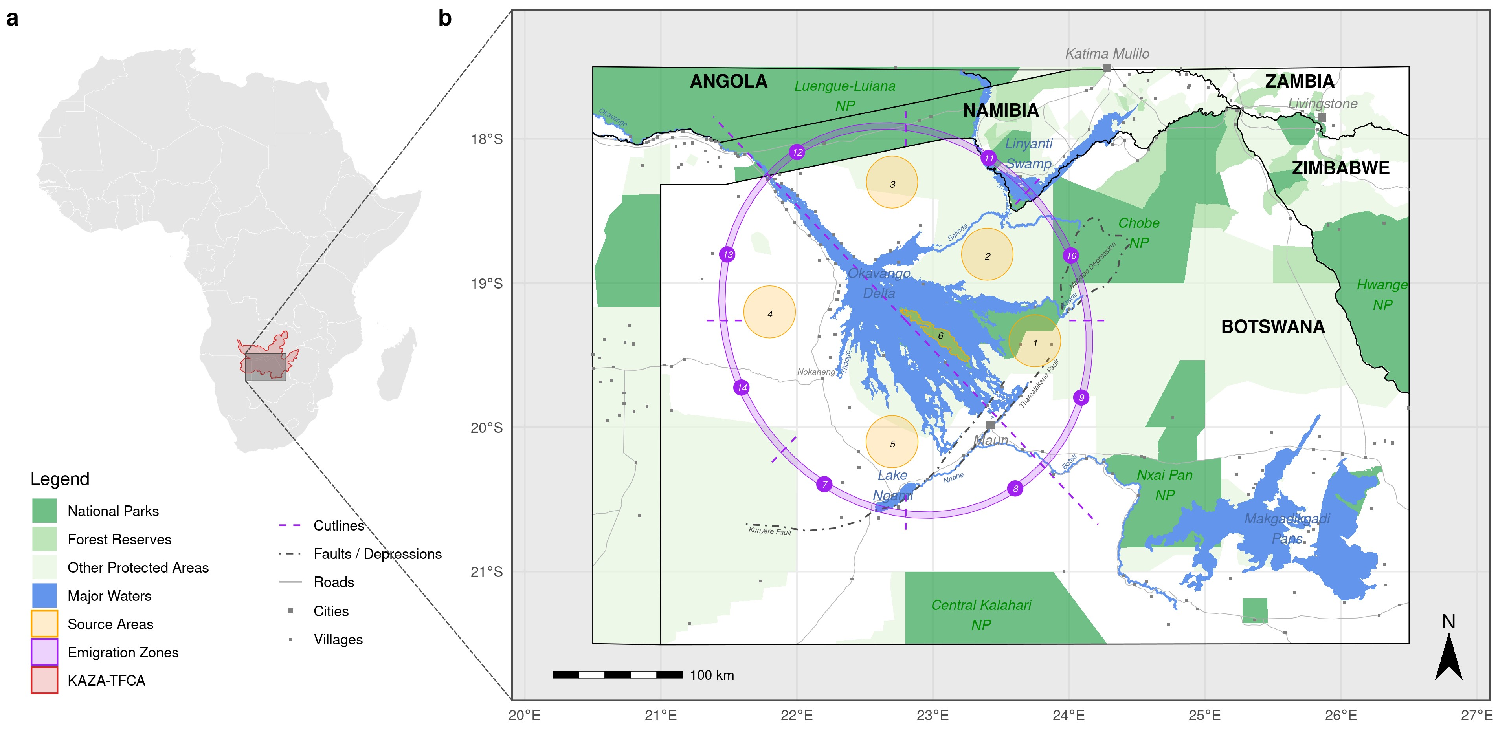

**Figure 1:** (a) Location of the study area, which forms part of the Kavango-Zambezi Transfrontier Conservation Area (KAZA-TFCA, red polygon) in Southern Africa. (b) The division of the core study area (enclosed by the purple polygons) in to sub-areas (1 to 6) was based on the hydrographic structure of the Okavango Delta and its tributaries. We simulated dispersal trajectories starting at random locations within each of the six source areas (orange polygons). Purple zones (7 to 14) represent “emigration zones” that we used to identify if and where simulated dispersers left the close surroundings of the Okavango Delta. These emigration zones were generated using a set of cutlines (purple dotted lines) originating from the center of the delta that dissected an elliptical buffer surrounding the delta into sections of equal size and in accordance with cardinal directions.

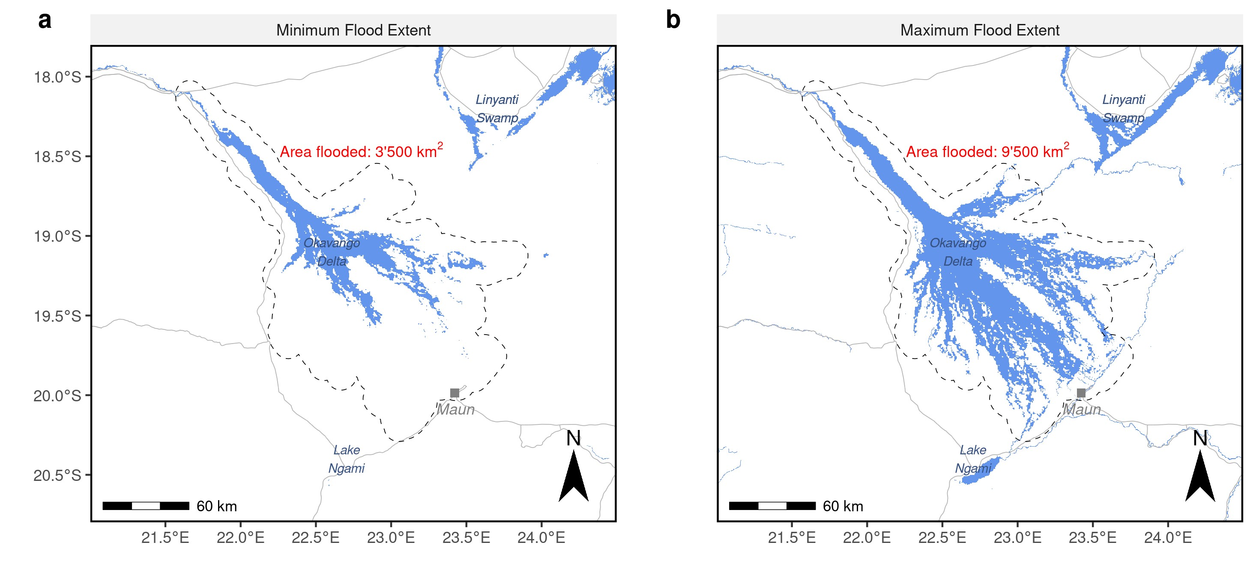

**Figure 2:** (a) Minimum and (b) maximum flood extent. The two maps were generated based on 100 minimum and 100 maximum floodmaps from a series of 700 remote sensed MODIS MCD43A4 satellite images spanning the years 2000 to 2019. Only pixels within the dotted polygon were considered to compute maximum and minimum flood extents.

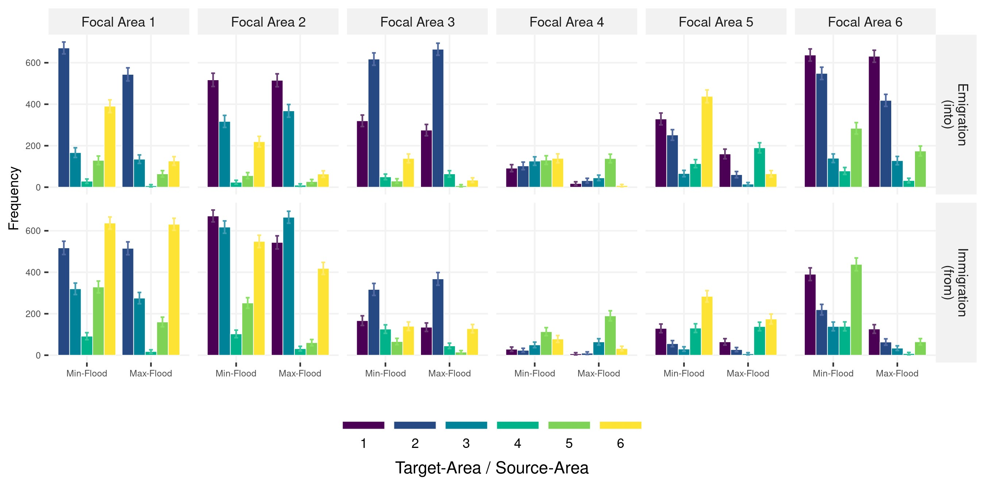

**Figure 3:** Number of individuals emigrating from, or immigrating into a specific source area (focal area). Colors indicate into which other areas emigrants moved or from which other areas immigrants originate. For instance, the most left plot in the upper panel shows the number of individuals moving from source area 1 into the six other source areas during minimum and maximum flood, respectively.

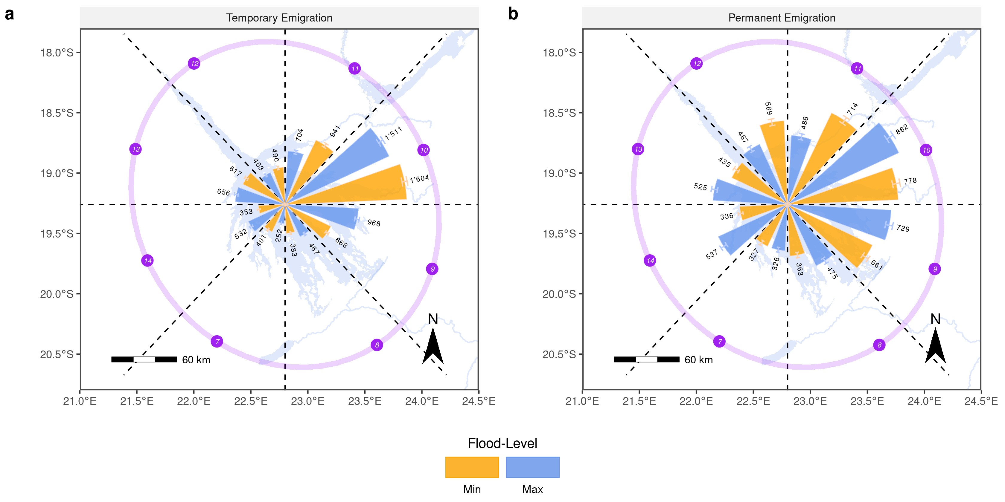

**Figure 4:** Absolute number of simulated trajectories running into each of the designated emigration zones (purple) during minimum and maximum flood. Subfigure (a) depicts the total number of emigrating trajectories, including temporary emigrants that eventually returned into the OD’s vicinity. Subfigure (b) only depicts permanent emigration events.

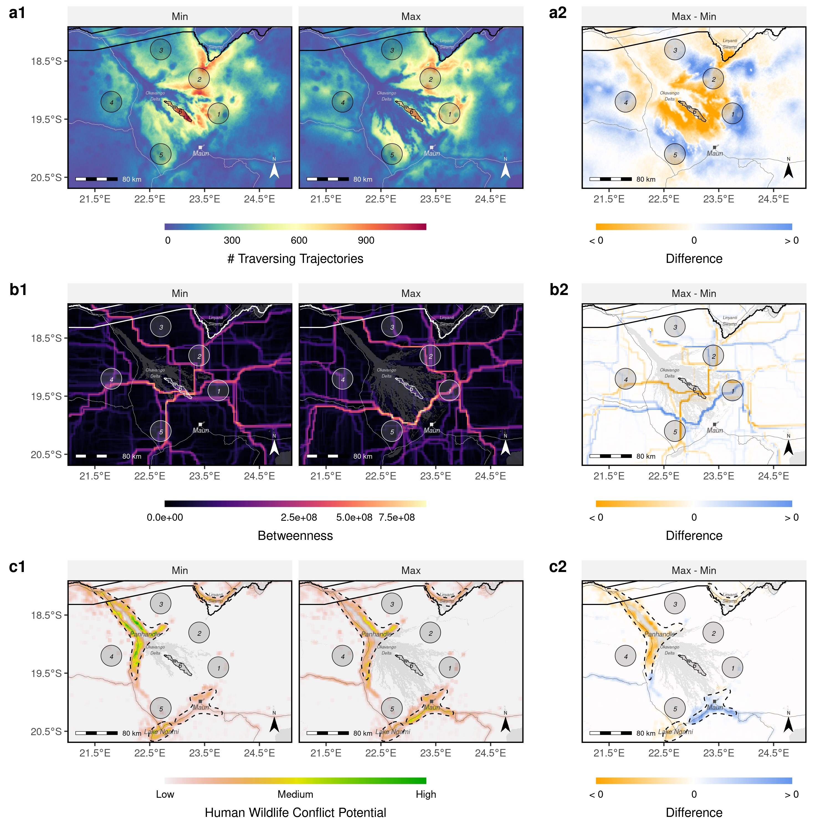

**Figure 5:** (a) Heatmaps, (b) betweenness maps, (c) maps of human wildlife conflict, and (d) maps of inter-patch connectivity, derived from simulated dispersal events. Left panels were derived from the minimum flood scenario, right panels from the maximum flood scenario. Source areas from which dispersers were released are numbered 1-6. The color scale for betweenness scores in (b) was square-rooted to improve visibility of corridors with lower values. Note that for clarity in (d) we only present links between adjacent source areas. Additional, source-specific maps for each of the four metrics are provided in the appendix.)

**Table 1:** (a) Dispersal frequency and (b) duration (in steps) between source areas (labeled 1 to 6) and emigration zones (labeled 7 to 14) during minimum and maximum flood.

